**Describing Web App**

Like all webpages, my web app will start on the *Home Page*:

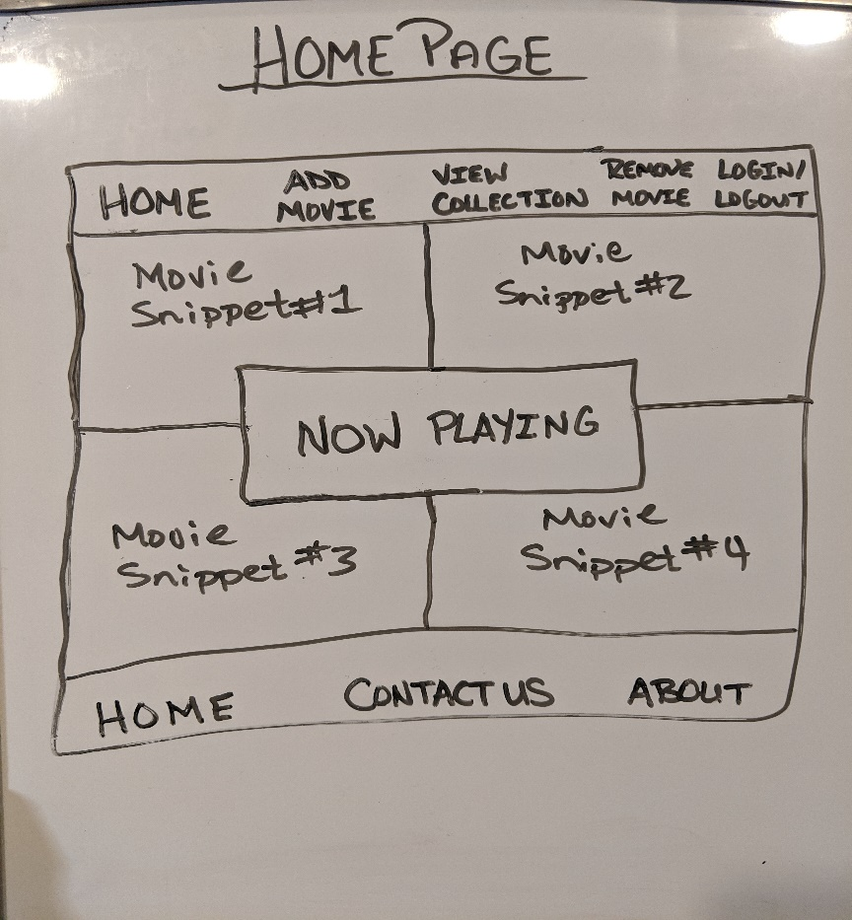

*\*Please note that “Home Page” written on the top is strictly for keeping track of the pictures and will not be shown on the web app\**

Here we have a header at the top of the Page. I am still deciding if I will put a title, or image above the header or leave it like this. The nav bar itself contains five links: HOME, ADD MOVIE, VIEW COLLECTION, REMOVE MOVIE, and the last link will state LOGIN if the user is NOT logged in. When the user logins in this will change to display LOGOUT which the user can click to prompt a confirmation alert. Once they select “yes” or “confirm” this will again revert back to LOGIN.

In the main body of this webpage are four blocks/quadrants. In each one I am hoping to have four small movie clips playing independently with no sound (to avoid a sensory overload). I will be exploring the option of having background music playing faintly on a loop that starts when the page loads (no controls for the user).

In the center of the page will be an image (if I can find the right one it will be similar to a movie sign you would see outside on a theatre) that I will have set as a link to the *Collection Page*. If I cannot find an image, or even make it work the way I intend I will simply have a colored block with the link displayed.

Finishing off the page is the standard footer with three more links: HOME, CONTACT US, and ABOUT. I didn’t really want to have the same links as the header as I think it would take away from the look. Instead, I have a HOME (incase the page is a little longer and requires scrolling), a CONTACT US link which will direct the user to a separate page with made up contact info and an ABOUT link which again will direct to another page with a description. I think I am aiming to do this web app design as though I owned a movie theatre and wanted to display my movies, thus the “Contact Us” and “About” links will be to pages like you would see on a company’s site.

If the user selects “ADD MOVIE” it will send them to the page that will allow them to add their own movie image as well as four elements that describe the movie which will follow the existing format. I did not include a picture for this page as I am still unsure of how I want to set it up. Most likely, it will be similar to how the example we did in class that allowed the user to insert a bicycle image only tidied up with some CSS. Because I have made the Header and Footer my template, they will be included on each of the webpages. Everything else will be dynamically generated.

The “REMOVE MOVIE” link will direct the user to a page specifically designed to remove a movie from the collection. Much the same as the “ADD MOVIE”, I have not drawn up a page for this one yet as I am up in the air as to the exact layout. It will have a place for the user to select the movie title they wish to remove and an alert box drop down for confirmation.

If the user clicks the “VIEW COLLECTION” link it will send them to the page that will provide access to view each movie image and the four text elements that will describe said movie. Here is a rough idea on what I will have for this page:

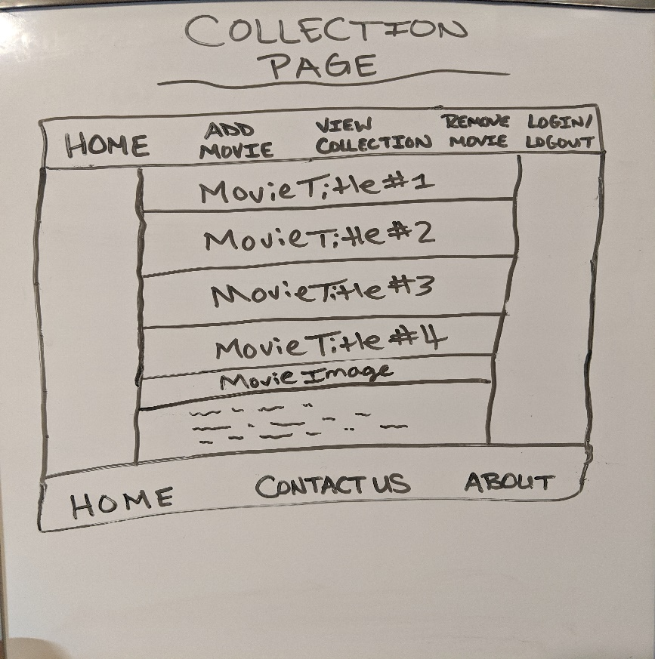

*\*Please note that “Collection Page” written on the top is strictly for keeping track of the pictures and will not be shown on the web app\**

There will be a row for each movie in the collection displayed. Describing each movie will only be the movie title. When the user selects a title (by clicking it) the title will slowly fade out and the movie image and text elements will slowly fade in. I will have this done so that only one movie can be displayed at a time. As one title is clicked the previous movie (if applicable) will fade out and the title will fade back in. Truthfully, I think this may be the only page where the user will make use of the HOME link in the footer as there could be quite a few movies to scroll through.

The LOGIN link will bring the user to the following page:

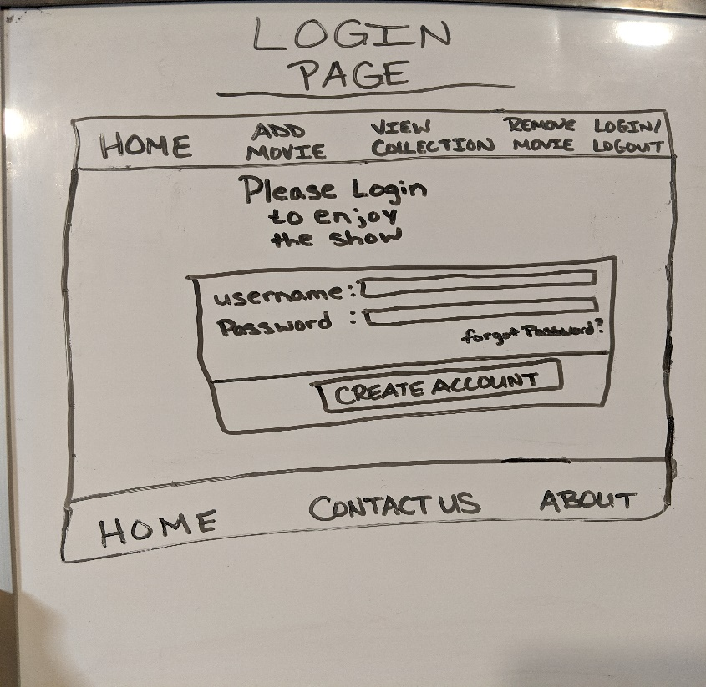

*\*Please note that “Login Page” written on the top is strictly for keeping track of the pictures and will not be shown on the web app\**

I am still undecided if I will simply have neat and simple text (as displayed) above the login form, or if I will instead have a nice image. I will have form validation for both the Username and Password that will check the database if the credentials match. If they do match, the user will be “Logged In” which will trigger the LOGIN link to say LOGOUT. If the user is like myself and very forgetful and cannot remember their password, they can click on the “Forgot Password?” link which will call an alert to drop down from the top of the page with a default password. Behind the scenes I will have the database updated for this username so the password now equals the default password so when the user enters it, they will be able to log in. I will play with things to see if I can up the security by having the default password randomize (This will depend on how far in over my head I am and what time I have left). This is the closest I can get to a realistic site where the password is emailed to the user.

If the user does **not** have an account, they can simply click the “CREATE ACCOUNT” button which will lead them to a creation page as shown below:

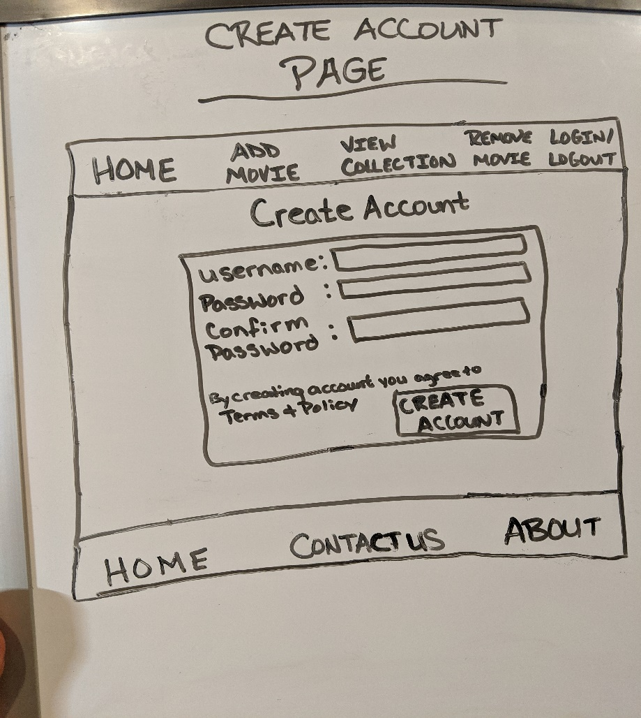

*\*Please note that “Create Account Page” written on the top is strictly for keeping track of the pictures and will not be shown on the web app\**

Similar to the Login form, this will request the user to fill in a desired Username and Password. In addition to the typical validation (Does this username already exist? Password must meet the following criteria, etc.) I have also included the “Confirm Password” text-box that will verify if the password entered is the same as the user entered the first time. To continue with my attempt of making this as authentic as possible I have added the Terms & Policy link. If I can get more familiarized with Jinja2 and what I can and cannot do with it (mainly if I can use jQuery plugIns) I will have either a small textbox appear (if I can use the plugin) or an alert box drop down with a small explanation. Once the user is satisfied with their username and password, they may click the “Create Account” button which will then redirect them back to the Home Page.

I will add as well, that in order to Add or Remove movies, the user must be logged in. I will have a Boolean in place to determine if loggedIn = true.

For both the CONTACT US and ABOUT pages, I will have some text neatly displayed with contact information incase there are any questions as well as a brief description about the movie theatre. This will be a case of I won’t know what I am doing until I am actually doing it so I cannot say for certain what will go where or how it will be displayed other than I will be looking to a typical Contact and About page for guidance on the layout.

When it comes to the grade I am aiming for, like anyone sensible I will be aiming for the best I possibly can. With that having been said, I know what I am capable of coding wise, and I also know that time is my biggest enemy (between other assignments and various activities that my kids are involved in), so I am realistically aiming for the 80-90% grade range. As in previous projects, commits are what kill me. I do not want to add 3 lines of code quickly one night for the sake of a commit as I feel that defeats the purpose of what you are asking.